Physical Domain - Frequently Asked Questions about Fine Motor

Introduction
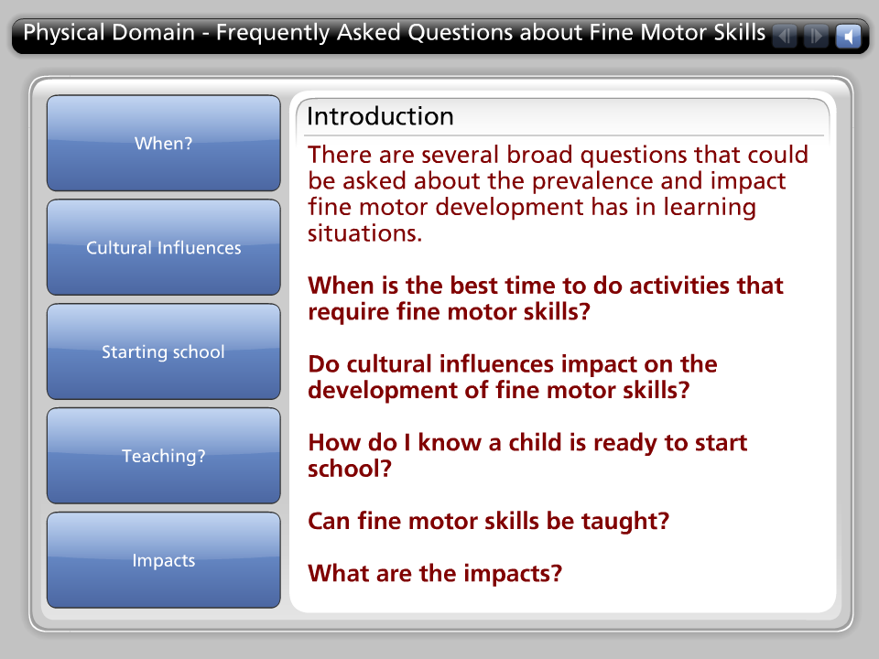
There are several broad questions that could be asked about the prevalence and impact fine motor development has in learning situations.

When is the best time to do activities that require fine motor skills?

Do cultural influences impact on the development of fine motor skills?

How do I know a child is ready to start school?

Can fine motor skills be taught?

What are the impacts?

When?

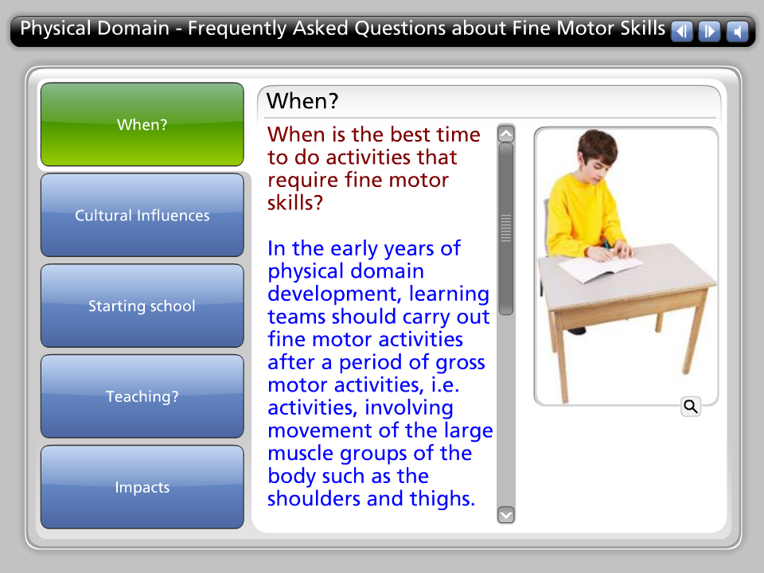
When is the best time to do activities that require fine motor skills?

In the early years of physical domain development, learning teams should carry out fine motor activities after a period of gross motor activities, i.e. activities, involving movement of the large muscle groups of the body such as the shoulders and thighs.

Fine motor activities started after gross motor activity or after a recess period when students have been active, work very well. The preceding gross physical work readies the larger muscle groups to act as the support and stabilizers required in fine motor activities.

Warm-ups work.

Cultural Influences

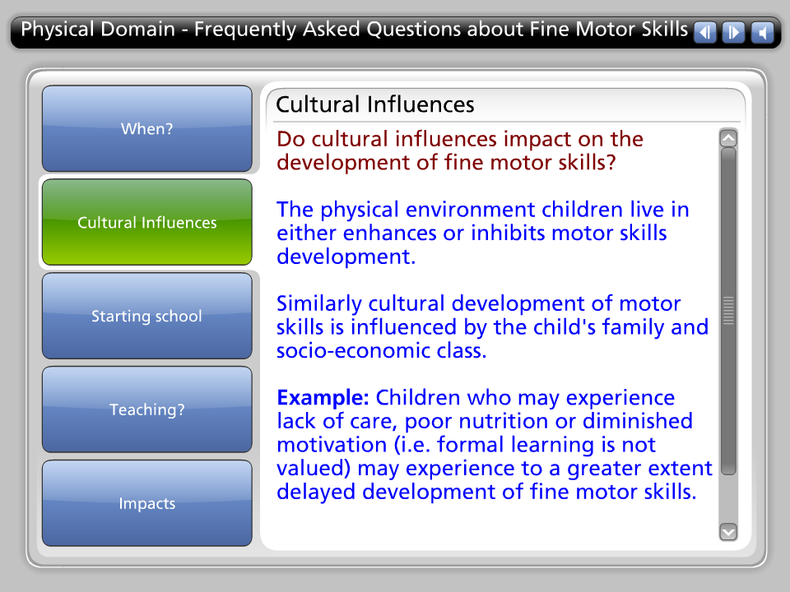

Do cultural influences impact on the development of fine motor skills?

The physical environment children live in either enhances or inhibits motor skills development.

Similarly cultural development of motor skills is influenced by the child's family and socio-economic class.

Example: Children who may experience lack of care, poor nutrition or diminished motivation (i.e. formal learning is not valued) may experience to a greater extent delayed development of fine motor skills.

Starting school

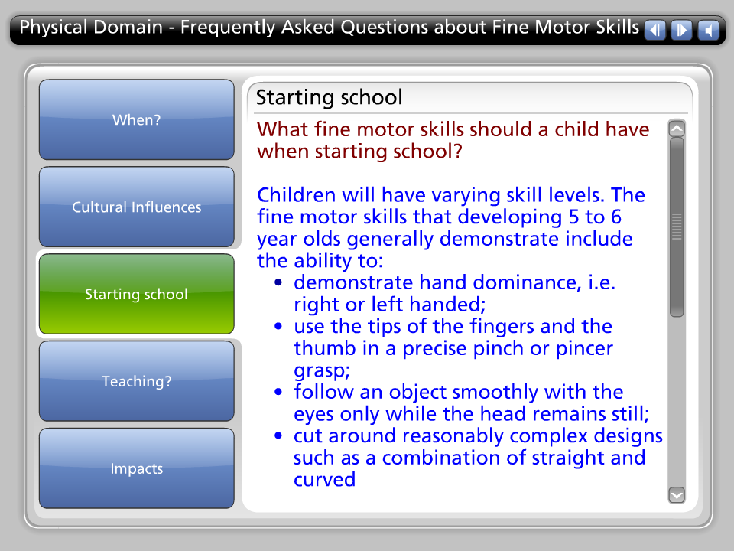

What fine motor skills should a child have when starting school?

Children will have varying skill levels. The fine motor skills that developing 5 to 6 year olds generally demonstrate include the ability to:
• demonstrate hand dominance, i.e. right or left handed;
• use the tips of the fingers and the thumb in a precise pinch or pincer grasp;
• follow an object smoothly with the eyes only while the head remains still;
• cut around reasonably complex designs such as a combination of straight and curved
• lines and corners, with less than 1 cm deviation from set lines;
• draw a circle, triangle, square, and a recognizable picture of a person and a house;
• use one hand to stabilize an object and the other to perform a separate activity such as unscrewing a lid and doing up buttons;
• manipulate small objects within the hand, e.g. rolling a marble;
• put together a complex, interlocking puzzle such as an age appropriate jigsaw;
• independently complete many self-care tasks, i.e. simple dressing, toileting, tying shoelaces and lunch set-up.

Teaching?

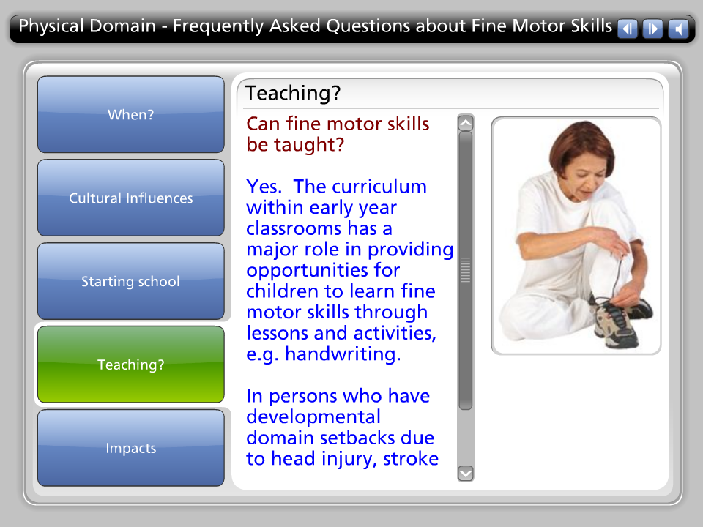

Can fine motor skills be taught?

Yes. The curriculum within early year classrooms has a major role in providing opportunities for children to learn fine motor skills through lessons and activities, e.g. handwriting.

In persons who have developmental domain setbacks due to head injury, stroke or other injuries, therapy activities are used to re-learn fine motor skills.

Impacts

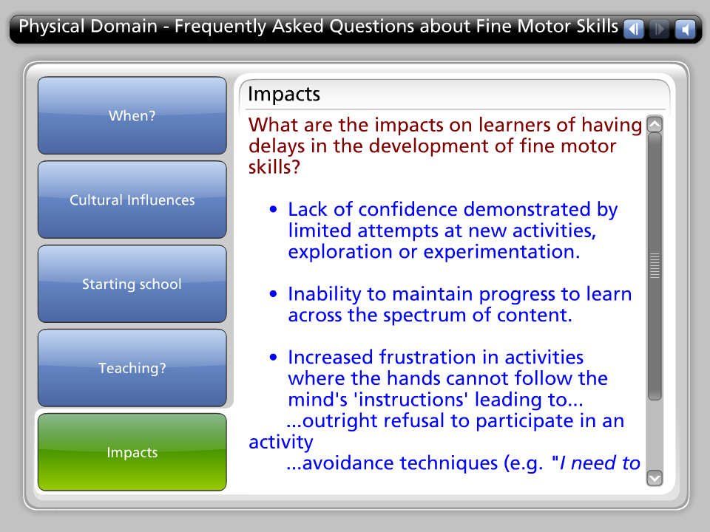

What are the impacts on learners of having delays in the development of fine motor skills?

• Lack of confidence demonstrated by limited attempts at new activities, exploration or experimentation.

• Inability to maintain progress to learn across the spectrum of content.

• Increased frustration in activities where the hands cannot follow the mind's 'instructions' leading to...
...outright refusal to participate in an activity
...avoidance techniques (e.g. "I need to go to the toilet")
...outbursts of anger or sadness (e.g. tantrums, crying)
...demonstrating ‘defeatist’ behaviour (e.g. "I can’t do this").

